Morning Praise @ Home 20th August 2023

Opening prayer
Blessed are you, God and Father of our Lord Jesus Christ, you have blessed us with every spiritual blessing; enable us by your power to be true to our calling and live holy and blameless lives before you all our days, through Jesus Christ our Lord, who is alive and reigns with you and the Holy Spirit, for ever and ever. Amen

Confession Let us admit to God the sin which always confronts us.
Lord God, we have sinned against you; we have done evil in your sight. We are sorry and
repent. Have mercy on us according to your love. Wash away our wrongdoing and cleanse us
from our sin. Renew a right spirit within us and restore us to the joy of your salvation, through
Jesus Christ our Lord. Amen cf Psalm 51
Absolution May the Father of all mercies cleanse us from our sins, and restore us in his image
to the praise and glory of his name, through Jesus Christ our Lord. Amen

Bible Reading Matthew 15: 10 – 20

Reflection from John INSIDE OUT – Matthew 15: 10 -20
MAY I ASK - HOW IS YOUR GUT TODAY?
I can distinctly remember a visit to a doctor in the RAF who took one look at my outward appearance with few clothes on and said: “Good grief Padre you look 4 months pregnant – lose 2 stone, man.”
I wanted to say to him “Underneath this lot is a genuine six pack” – but I don’t think he’d have been impressed. In a more recent visit, the doctor had been looking at me more deeply and has sent me for a few X rays. He is looking inside.
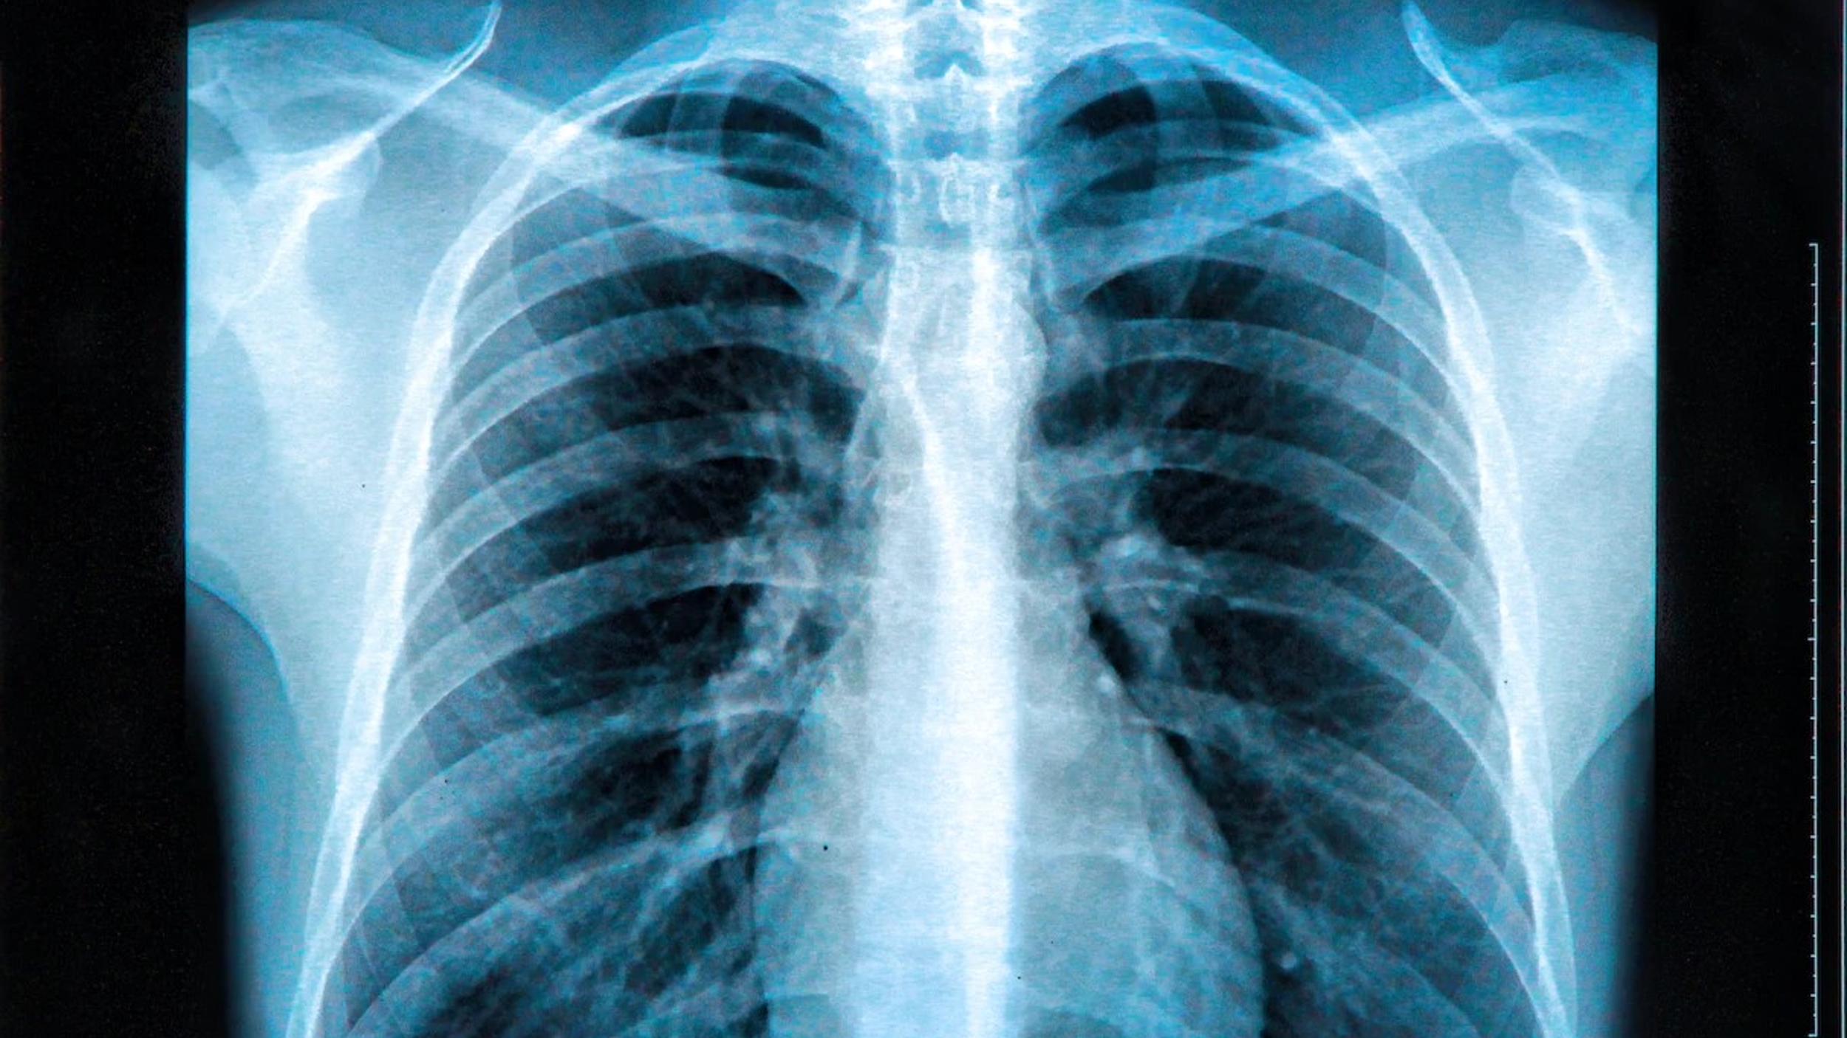
Looking beyond the superficial to inside a human being is fascinating. What makes someone tick? What’s going on behind the scenes? What’s ailing them that you cannot see?
So in our set Bible reading for today Jesus was responding to the Pharisees who criticised his followers for not following their OUTWARD rituals - pre-meal handwashing, for not following Sabbath restrictions and for associating with those they regarded as unclean...
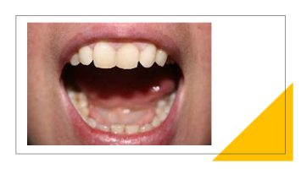
At the heart of this passage lies a proverb from Jesus “It is not what goes into the mouth that defiles a person, but it is what comes out of the mouth that defiles.” (Matthew 15:10).
Jesus knew full well that even the best-intentioned outward observances can become substitutes for devotion to God while our hearts are occupied with thoughts that promote our agendas and whittle others down to size. Alas it is possible to honour God only with our lips while our hearts are far removed from God. (Matthew 15:8).
In other words what is going on inside our hearts and minds is crucial to our spiritual and emotional wellbeing. If we are messed up within……it will reveal itself in our words and our actions.
So Jesus invites us to look out over the expanse of our culture, our church community, and our personal lives to see if there are any situations that stand in need of its pithy but powerful challenge - “It is not what goes into the mouth that defiles a person, but it is what comes out of the mouth that defiles.” (Matthew 15:10).

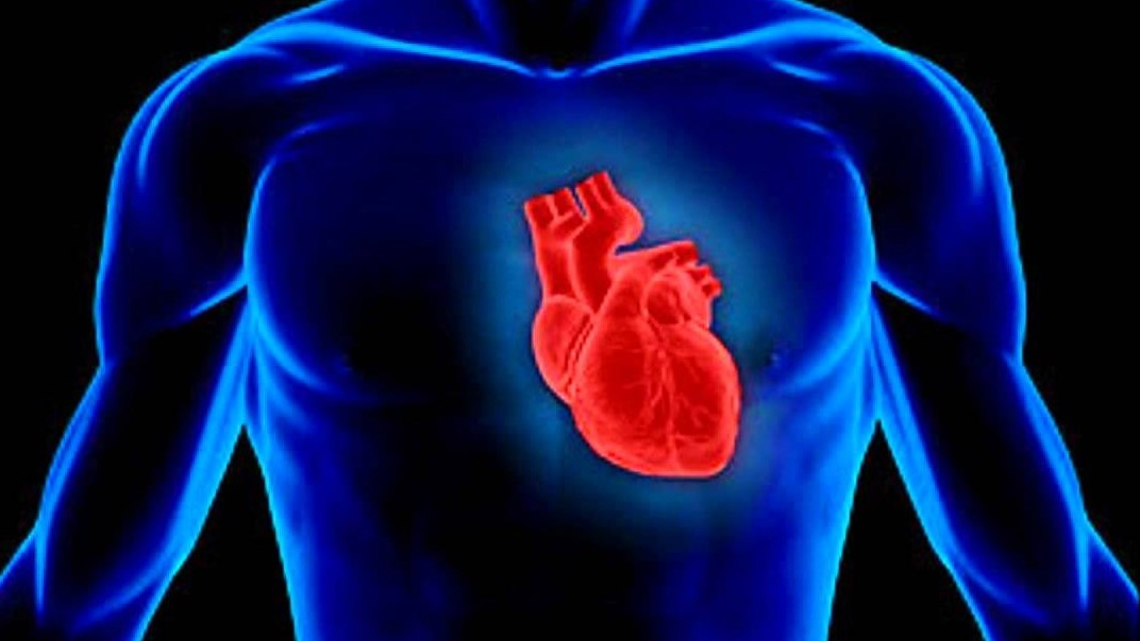
To have a healthy relationship with God and other people we might need heart surgery
– what comes out of our mouths can be an indicator of a deeper sickness.

That’s why Jesus in our passage insists that harmful words express evil intentions that lead to harmful deeds.

Scripture bears Jesus out with its catalogue of murderous, adulterous, false and thieving words. “It is not what goes into the mouth that defiles, but it is what comes out of the mouth that defiles.”
What we say comes straight from our hearts. For Jesus’ listeners the heart was not a faculty separate from the mind, but the seat of emotions, intellect, will and spiritual life. Our words come from our hearts and often, they head straight for the heart of another. If the heart is a poisoned well, it has great potential to destroy with words.
“Blessed are the pure in heart,” says Jesus in the beatitudes, “for they will see God” (5:8)
The Old Testament background to the notion of a pure heart is Psalm 24:4 in which access to God’s presence during Temple worship is for the one who has ‘clean hands and a pure heart.’

“Those who have clean hands and pure hearts, who do not lift up their souls to what is false, and do not swear deceitfully, They will receive blessing from the Lord, and vindication from the God of their salvation.”
Outward appearances aren’t enough. The heart must also be pure. The pure in heart are those who are spiritually pure rather than just ritually or ceremonially clean. That is why Jesus was so tough on the Pharisees. He looks deeper.
The pure in heart recognize their need for God; they empathize with and extend comfort to others; their lives are graced by daily deeds of compassionate forgiveness to those who wrong them.
When our hearts are pure, our words are loving.
And when our hearts are pure, and our words are loving, our deeds usually follow.
And when our words and deeds are loving, our lives have great power to heal and bring joy to those around us.
The flip side of Jesus’ paradoxical proverb about defiling words is a positive insight about the power of purifying words.
It is not what goes into the mouth that purifies a person, but it is what comes (from the heart) out of the mouth that purifies. That goes for both the sender and the receiver.
Most people get heart checkups and start watching what goes into their mouths. Jesus recommends that we check out our hearts and then start watching what comes out of them!
Affirmation of faith
Do you believe and trust in God the Father, source of all being and life, the one for whom we exist?
We believe and trust in him.
Do you believe and trust in God the Son, who took our human nature, died for us and rose again?
We believe and trust in him.
Do you believe and trust in God the Holy Spirit, who gives life to the people of God and makes Christ known in the world?
We believe and trust in him. This is the faith of the Church.
This is our faith. We believe and trust in one God, Father, Son and Holy Spirit. Amen
Prayers of intercession led by Philip
Dear Lord
We thank you for our time of worship together this morning. We thank you that we are able to meet as friends, as a part of our local community and as a part of your worldwide church. We pray for those who
cannot meet and openly worship, many in places where they are persecuted for their beliefs. Give them strength Lord and protect them.
Lord in your mercy, hear our prayer
Father as we look back on the week just past, we thank you for any things that have made us smile, for any positive meetings we have had with friends, neighbours or work colleagues. We thank you for the sense of community that we are able to enjoy and Lord having experienced the isolation of the Covid lockdowns, we do appreciate the importance of face to face meetings throughout the week.
We think now of those who for whatever reason feel isolated and bereft of human contact. They might be elderly and unable to get out and meet, they might be ill, they might just be wary of social contact. Father we ask that you might give them the knowledge of your presence, but also that you encourage those of us who are able to get out and about to remember those we know who might be isolated and to do what we can to help them with companionship and friendship.
Lord in your mercy, hear our prayer
As we near the end of the school holidays we pray for those families on their holidays. We ask for them to have special times together and to be able to relax. We think also of those children who feel stressed and isolated, who fear social media and feel they are missing out on the fun everyone else seems to be having. Actually Lord we pray for the adults who feel the same. Be with them all, comfort them. Help parents and all carers to create happy and stable environments so that the children in their care might grow strong and have healthy relationships.
Lord in your mercy, hear our prayer
We pray for all those affected by violence and war. We pray for those fleeing these situations and in particular think of those who are desperately risking their lives in sea crossings hoping for new lives. We think of those who have lost family and friends, who are left waiting at home for news. We ask for justice and compassion in our treatment of all refugees.
Lord in your mercy, hear our prayer
We pray for this church. For our vicar John and all those involved in the many tasks that form part of our service to you. We ask for your guidance as we seek a youth and children’s worker. We ask that you inspire the right candidate for this role.
Lord in your mercy, hear our prayer
We pray for the Open the Book teams as they meet to plan the bible stories to present in our local primary schools for the new academic year. We pray for the Messy Church leaders and helpers as we plan events for the Autumn.
Merciful Father, accept these prayers for the sake of your Son, our Saviour Jesus Christ. Amen

The Lord’s Prayer As our Saviour taught us, so we pray

Our Father who art in heaven, Hallowed be thy name, Thy kingdom come, Thy will be done, on earth as it is in heaven. Give us today our daily bread. And forgive us our trespasses as we forgive those who trespass against us. Lead us not into temptation but deliver us from evil. For thine is the kingdom, the power and the glory forever and ever. Amen

Closing prayer
God give you grace to become the people He has called you to be, that you may live and work to his praise and glory, and the blessing of God Almighty, Father, Son and Holy Spirit be with us and remain with us always. Amen
Go in peace to love and serve the Lord. In the name of Christ. Amen

